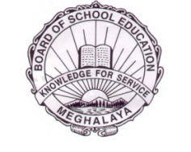
MEGHALAYA BOARD OF SCHOOL EDUCATION
HEADQUARTERS::::TURA

MBOSE/ITES & REGN/Misc 2 (a)/15/ 27184 Dated Tura, the 26th October, 2023

From :- Shri. J. S.Sangma,
Dy. Director, (ITES & Reg.)
Meghalaya Board of School Education,
Tura.

To :- All the Head of the Institutions,
Secondary Schools of Meghalaya.

Subject:- Issue of Registration card of Class- IX (Nine) for the year 2023.

Sir/Madam,

With reference to the subject mentioned above, I am directed to inform you to kindly collect the Registration Card of Class IX (Nine) 2023 from Meghalaya Board of School Education, Tura/ Shillong/Jowai during office hours w.e.f. 27th October, 2023.

Yours faithfully,
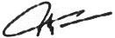

(J. S. Sangma)
Dy. Director, ITES
Meghalaya Board of School Education,
Tura.

…………..

